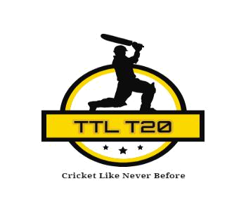

TTL-2020 waiver of Liability and Release form-Nashville Tennessee Cricket League

WAIVER: I know that participating in a cricket event is potentially hazardous, and that I should not enter to participate unless I am medically able and properly trained. I HEREBY ASSUME THE RISKS OF PARTICIPATING IN THIS EVENT. I certify that I am physically fit and that I have sufficiently trained. I agree to abide by the competitive rules. I hereby take the following action for myself, my executors, administrators, heirs, next of kin, successors and assigns, or anyone else who might claim or sue on my behalf, and I hereby waive, release and discharge from any and all claims, losses, or liabilities for death, personal injury, partial or permanent disability, property damage, medical or hospital bills, or theft which may arise out of or relate to my participation in this event. I agree not to sue, and to hold harmless any and all persons, sponsors, volunteers, participants, Tennessee Twenty League Organization Committee or its associate teams or government agencies for any and all claims or liabilities that I have waived, released or discharges herein.

Team Name:
Date:

Full name Signature Date

1.

2.

3.

4.

5.

6.

7.

8.

9.

10.

11.

12. (Super Sub):

