NTCL PRESENTS
LEWISBERG T20 BASH CHAMPIONS LEAGUE

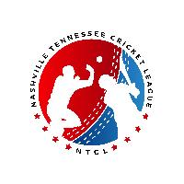

Table of Contents
- The Spirit of Cricket 3
- Covid Guidelines and Instructions 4
- Organizers 4
- Rules and Regulations 5
  - Player Identification 5
3.2 Declaring Playing XI..............................................................................................................
- Match timings and Punctuality 5
  - Players 6
  - Umpires 6
- Umpiring in NTCL 7
- Match Forfeiture Policy 7
- General Rules 8
  - No-ball policy 8
  - Free hit policy 9
  - Wide ball policy 9
  - Retired hurt policy 10
  - Caught behind decisions 10
  - Umpires Reversing the decision 11
  - Breaking Stumps during Runouts / Stumping Appeals 11
- Umpiring Responsibilities 11
- Captain’s Responsibilities 12
- Tournament Format 13
- Penalties 15
- Player / Team Conduct 16

The Spirit of Cricket
Cricket owes much of its appeal and enjoyment to the fact that it should be played not only according to the Laws, but also within the Spirit of Cricket.
The major responsibility for ensuring fair play rests with the captains but extends to all players and umpires.
Respect is central to the Spirit of Cricket.
Respect your captain, team-mates, opponents and the authority of the umpires. Play hard and play fair.
Accept the umpire’s decision.
Create a positive atmosphere by your own conduct and encourage others to do likewise. Show self-discipline, even when things go against you.
Congratulate the opposition on their successes and enjoy those of your own team. Thank the officials and your opposition at the end of the match, whatever is the result.
Cricket is an exciting game that encourages leadership, friendship and teamwork, which brings together people from different nationalities, cultures, and religions, especially when played within the Spirit of Cricket.

Organizers
Basic Exceptions:
Protective gear is strongly recommended, and it is solely the players decision regarding the gear to use while considering the safety during the course of the game. Gloves for fielding is strictly not allowed. Only wicket keeper can use gloves.
Boundary dimensions are 70 yards from the center of the pitch and should be measured by tape to maintain consistency on G1 and G4. The “Inner Circle” has been marked at 30 yards from the center of the pitch. (For the 360-ground).

Covid Guidelines and Instructions
- The Centers for Disease Control and Prevention and World Health Organization offers recommendations on best practices for the general public and how to help prevent the spread of COVID-19. Among other things, these recommendations currently include:
    - Thoroughly wash hands with soap and water thoroughly for at least 20 seconds, or use an alcohol sanitizer with 60% plus alcohol content as advised by the CDC
- . • Carry hand sanitizer with you when leaving the house.
    - Avoid touching or contacting others when out in public. No handshaking, fist pumps, hugs etc.
    - Wear a face mask that covers your nose and mouth when in public settings.
    - Avoid putting hands in your mouth, eyes or nose.
    - Cover your sneezes (sneeze into crease of elbow) and coughs or use a tissue.
    - Clean and disinfect frequently touched surfaces and exercise equipment, light switches, doorknobs, water fountains, door handles, mobile phone, car keys, computer keyboards, etc.
    - Stay home if you are sick or have any symptoms.

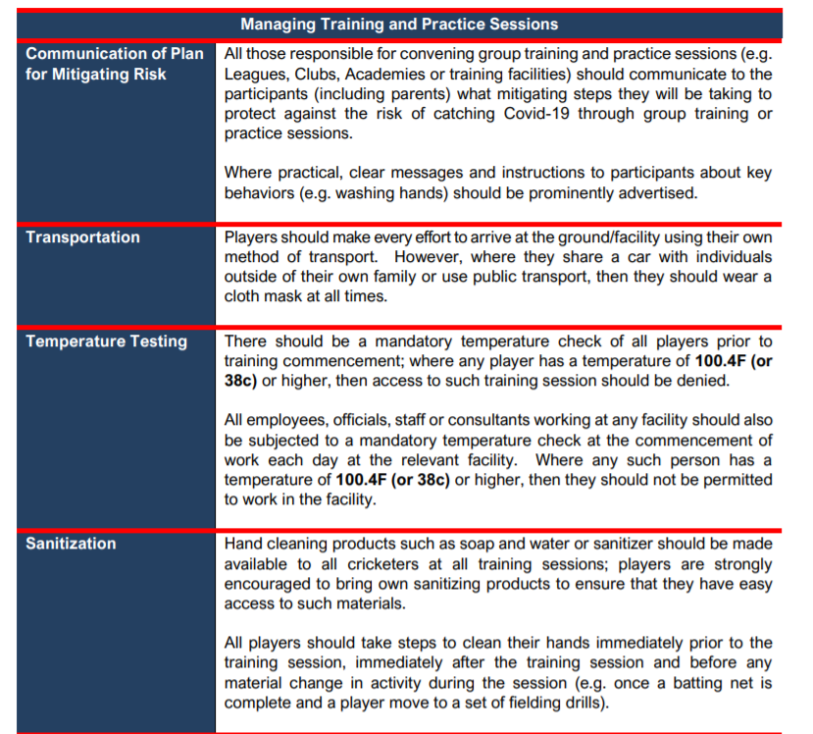
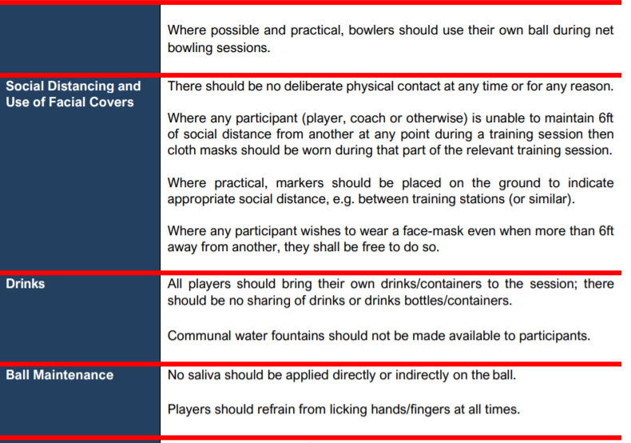

NTCL Rules and Regulations

Player Identification:
All teams need to upload their team player rosters and player images (Mandatory) to the NTCL website prior to the provided deadline.
Tournament Roster Size: Each team will be allowed to carry an active roster of 25 players. Players can be added/dropped as per the tournament deadlines set by the Organizers.

Match Timings and Punctuality

Players
At least 8 players of a team have to be present 15 minutes before the start of their game. Failing to do so will result in the automatic loss of toss for the team in question.
In case both teams are missing players then the one with more players present on the ground at the start of the game are declared as toss winners (as long as one team has 8 or more players present).

If neither team has at least 8 players available to start the match on time, then the team who gets 8 players first wins the toss and other team will be penalized with reduced overs while their batting.
If any team(s) unable to get at least 8 players in 30 minutes after the scheduled start time, then the team with higher number of players will awarded with winning points. If both teams have equal but less than 8 players after 30 minutes, then points will be shared.
To calculate the revised number of overs, umpires should reduce 2 overs for every 15 minutes lost from their batting inning.
e.g. If other team gets 8 players 20 minutes late, then their batting inning needs to be reduced by 4 over and if they get before 15 minutes then their batting inning will be reduced by 2 overs to accommodate for the late start.
In the event that a match is delayed due to only one team not being present at the ground, the umpires may revise the match structure as follows:
Team that was on time and ready to play will be allowed to bat 20 overs and wins the toss.
For games that start late, both umpires and captains need to ensure that the match ends by the stipulated end time by minimizing/cancelling drink breaks and or innings breaks to make up any lost time.
Umpires will ensure that teams do not waste time by frequent huddling/discussing strategies especially during tight games.
The first ball needs to be bowled by the designated start time of the match to ensure that no games get interrupted due to late starts.
If for some reason the match cannot be started on the stipulated start time, both captains should agree to play a reduced-over match based on the (above-mentioned guidelines in #4) to ensure that the match can finish on time.

Umpires
Umpires need to be at the ground at least 15 minutes before the stipulated start time to ensure that the coin toss and boundary setup is performed before the match start time. Failure to do so will result in a penalty for their team.
In the event that umpire is unable to get to the field on time, they should proactively call ahead to the playing Captains to inform them of their delay and estimated time of arrival.
Captains need to ensure that they only send umpire that are knowledgeable on general cricketing rules, have read and understood the NTCL rule book, and can confidently officiate NTCL matches.

Team’s captain hold responsibility for dedicating umpiring to next ground
Any missing umpiring will result in 2 points loss first the first time and going forward it would be both 2 points loss and financial penalty ($50 per game)

Match Forfeiture Policy
The committee wants to discourage teams for forfeiting their games as its repercussion affects in so many ways. Hence, teams that forfeit will be penalized.
When is a match forfeited?
A match will be considered forfeited under one of the following conditions: A Team is a No-Show for a match or refuses to play the match
A Team violates the Minimum Player Rule
A Team violates NTCL conduct policy - resulting in the umpires calling the game off and awarding it to the opposition.
What Happens after a Game is forfeited?
The offending team may/will be penalized with loss of deposit, player, and/or team suspensions. NTCL Organizers will take into consideration the events leading to the forfeiture and inform teams accordingly of the outcome.
The opposition will be declared as the ‘match winners’ and awarded the full points to winners.
No NRR allocation will be applied to forfeited games. If offending team is playing their last game and not qualified for playoffs, then penalty may be applied on next league or season.

General Rules
Once the team rosters are finalized and locked on the NTCL website, player transfers between teams is not allowed unless approved by the Organizers.
Any conspicuous movement by a fielder/wicket keeper once the bowler starts in his bowling stride to the instant that the ball is delivered is prohibited. The umpire will have the discretion in what is meant by conspicuous.
Also note that in the case of run-outs and stumping, a batsman is out of his ground unless a part of his bat or body is grounded inside the crease. Thus, if the body or the bat is grounded on the crease line, but not inside, the batsman is “OUT”.
Either batsman can be adjudged “RUNOUT” if they are out of their crease even if the ball only made contact with the body/clothes. Even though leg-byes don’t count towards a score, the

batsman needs to ensure that he is in his crease to avoid being run out. The only exception is if the umpire calls it a “Dead-play”.
Any abnormal bounce or lack of it due to the condition of the pitch will be signaled a “Dead- ball” by the umpire and the delivery will need to be re-played. Any scoring or wickets due to such an instance will not be considered. Captains need to ensure that their bowlers do not have any “suspect” bowling actions. Umpires will issue a warning to a bowler if his bowling action seems “suspect”. If there is a repeated occurrence, then the umpires can prohibit the bowler from bowling in the match. Another bowler will need to be used to make up the bowling over/quota.The Wicket-Keeper is allowed to bowl provided he is off of keeping duties for at least 1 over before he bowls.
After the bowler starts his run up fielders/wicket keeper are not allowed to talk or move side- ways. Such actions will result in the umpire signaling a No-Ball.
Since some venues require longer commute times, neutral umpires and playing team captains should communicate with each other ahead of arrival to the ground to ensure that there everyone is aware of any arrival delays that could affect the match start time.
If both teams arrive at the ground and discover that the playing conditions are not suitable for a match, both captains and umpires should contact a non-involved member of the NTCL Organizers/Advisory Panel immediately to determine the next course of action. The organizers will try to re-locate the game to another venue if possible or provide re-scheduling options to both teams.
A batsman will not be allowed to retire only to come back in the innings later to bat, unless he is retired hurt.
Injuries are common in sports and Cricket is no exception. All players should have health insurance and will not hold the organizers responsible for any injuries they may sustain during the tournament.
This is a not-to-profit community event and by playing in this tournament you waive your right to sue any organizers/volunteers for any financial woes/issues.
If a team walks out during the match or does not show up for a match, they will forfeit the match and 2 points will be awarded to the opposing team. Also team will forfeit their deposit and might not be included in future NTCL tournaments.

No Ball
No-Ball due to Height Any bouncer over the head or beamer above waist will be called a No- ball. One bouncer above shoulder and below head level is allowed per over. For bouncers and beamers, the batsman's movement in the crease right before the delivery is bowled will be taken into consideration (i.e. a bouncer above the head becomes a legal delivery for batsman charging down the wicket)
The leg umpire will be the primary authority for signaling a No-ball due to height. The main umpire should consult with the leg umpire before declaring a No-ball due to height. One legal bouncer per over is permitted

Wide-Ball
Both Umpires need to be consistent about whether they will call a Wide-ball from a mark on the pitch or on the merit of the ball for both innings.
Both captains should be clear about how the umpires are going to call before the match to ensure no arguments take place during the game.

Free-Hit
Per ICC Law 24.2 Free Hit after a foot-fault no ball - the delivery following a no ball called for a foot fault (Law 24.5) shall be a free hit for whichever batsman is facing it. If the delivery for the free hit is not a legitimate delivery (any kind of no ball or a wide ball) then the next delivery will become a free hit for whichever batsman is facing it.For any free hit, the striker can be dismissed only under the circumstances that apply for a no ball, even if the delivery for the free hit is called wide ball.Field changes are not permitted for free hit deliveries unless there is a change of striker (the provisions of clause 41.2 shall apply).

The umpires will signal a free hit by (after the normal No Ball signal) extending one arm straight upwards and moving it in a circular motion and/or verbally communicating it to the batsman/bowler.
“Mankading” (Bowler attempting to run out non-striker before delivery)
As per the ICC Law 42.15, the bowler is permitted, before entering his delivery stride, to attempt to run out the non-striker. The ball shall not count in the over.
The umpire shall call and signal “Dead ball” as soon as possible if the bowler fails in the attempt to run out the non-striker.
Before attempting to dismiss, one warning needs to be given to the non-striker.

Catches on Boundary Lines
Umpires will make the decision on this subject based on his/their best judgment. Umpires can take the catcher or the next close in fielder input if they need to but it is not mandatory.
Batting team / Fielding team players should not interfere in this situation nor should they charge towards the boundary line or into the field.
Captains should instruct their players to hold their position for any controversial catches/fielding attempts near the boundary prior to the match.
If a player should move from their position after the play, and the umpire is unable to pinpoint the exact spot, then the benefit of doubt should be given to the batsman.

Retired Hurt Policy
A batsman will only be allowed to retire due to injury during the game not prior condition. A batsman cannot be retired by teams based on their batting performance.

A batsman can only be retired if they have sustained an injury that prevents them from continuing. The umpires will make the judgment to assess on whether a batsman's request for retirement should be granted based on their own observations.
However, they are permitted to return to batting after the fall of the next wicket or after the retirement of another batsman.
A batsman who retires due to some other reason except injury during the game cannot come back for batting.

Caught Behind Decisions
Caught-behind decisions need to be made by the main umpire. He can take into consideration any evidence from the leg umpire (e.g. sounds) but the final decision needs to be made by the

main umpire to ensure a fair decision. Caught-behind decisions CANNOT be solely made on sounds heard by the leg umpire but rather need to be based on other factors not visible to the leg-umpire (e.g. deflection, deviation, angle, etc of the ball)

Umpires Reversing their Decision
Umpires decision will be final. However, umpires are encouraged to consult the leg umpire for any doubtful decisions. He can consult with the leg umpire for clarification or can decide himself to reverse his decision promptly if he thinks he was wrong initially. His priority is to give the right decision.
Umpires should take their time in making a final and correct decision and not feel pressured from either of the teams.

Breaking Stumps during Run-Outs / Stumping Appeals:
If the stumps have been broken once i.e. bail(s) have been dislodged, or stumps been hit (if playing without bails) during the course of an on-going play, then to successfully appeal for an ensuing run-out / stumping, the fielding side will have to manually uproot at least one of the standing stump(s) with the ball in possession.
If none of the stumps are standing up due to an earlier displacement, then the fielding side needs to re-insert one stump and then uproot it again with the ball in possession in order to successfully appeal for a dismissal.

Umpiring Responsibilities
Neutral umpires will adjudicate each game.
They are the final authority during the game and their decisions will be considered final. They will always remain impartial on the field.
They will keep track of the number of overs during which a fielder has left the field.
The coin-toss will be conducted in the presence of the neutral umpire before the stipulated match start time. The team winning the toss will declare its decision immediately. Captains or their representatives for the toss should be ready for this ahead of the match start time. If the neutral umpires are not present by the match time then the captains should proceed with the coin-toss in the interest of starting the match on time by utilizing an umpire from the batting side.
Umpires will keep time of all breaks, and notify the captains as to when to resume.

They should file a complaint about any misconduct by a player or a team on the field with the NTCL Organizers/Advisory Panel.
Umpires should check the pitch and the ground to see if it meets the basic requirements as in the ground standards, including the suitability of the outfield for play when it rains. They should periodically check the condition of the ball and decide on a replacement if applicable.
Umpires decision will be final. However, umpires are encouraged to consult the leg umpire for any doubtful decisions. He can consult with the leg umpire for clarification or can decide himself to reverse his decision promptly if he thinks he was wrong. His priority is to give the right decision.
Any team that is scheduled for umpiring duties and is either unwilling to send umpires or does not send any umpires on the day of the scheduled match will be penalized.
If for any reason the umpires do not show up for the match, the captains are responsible to contact Organizers. The main aim is to play the match and play it supportively. The Organizers will enforce any deemed penalties on teams not honoring their umpiring duties.
The Organizers will make decisions in cases of disputes that could not be resolved during the game by the neutral umpire. Evidence provided by the neutral umpire and the two captains will be used to make a final and binding decision that will need to be abided by.
The neutral umpire’s decision will be final for events close to the boundary line (catching, 4’s, 6’s). The umpire can consult with the nearest fielder to make such decisions. Fielding teams should instruct perimeter fielders to remain at the spot of the fielding so that umpires can make the best possible judgment in such instances.
The main umpire will have authority to over-ride leg-umpires decision except on stumping and run-out decisions.
Caught-behind decisions need to be made by the main umpire. He can take into consideration any evidence from the leg umpire (e.g. sounds) but the final decision needs to be made by the main umpire to ensure a fair decision. Caught-behind decisions CANNOT be solely made on sounds heard by the leg umpire but rather need to be based on other factors not visible to the leg-umpire Ex:
deflection, deviation, angle, etc of the ball)
The leg umpire’s jurisdiction covers decisions on run-out/stumping/no-balls due to height decisions at the striker’s end. Additionally, from his vantage point, a leg umpire can opine on whether a wicket-keeper/fielder has cleanly collected a catch, ball crossed the boundary, fielder placements inside/outside the circle, and on leg/off side fielder counts.

Captain’s Responsibilities
One player from each team will act as team Captain for the duration of the match. They should control the behavior of all his team players. (Conduct of his team.) Ensure the team players respect the umpire's opinions and decisions.
Captains are responsible for ensuring that the boundary cones/flags are measured and setup before the match start time.
Both captains should ensure that their respective teams share the responsibility of placing/removing the outside/inside flags and cones as before and after each match.
They will be responsible for going over the NTCL Rules and Regulations with their players.
It’s the captain’s responsibility to make sure that the players tasked for umpiring duties are aware of and understand the NTCL Rules and Regulations.
Captains are responsible for ensuring that all match venues are cleared of any debris/trash at the end of the match. Since NTCL co-shares its venues with other groups it is imperative that teams do not leave behind any debris at the ground. Both teams run the risk of being penalized at the discretion of the Organizers if an official complaint is lodged with NTCL with regards to leftover debris
The umpire should not be pressurized in any circumstances. It will be captain’s responsibility to make sure nobody crowds or threatens the umpire. Neutral umpires in conjunction with the Organizers will have authority to abandon a game and award points to whoever they think are the deserving winner in case of a fight/controversy.

Points System
Winning: 2 points are awarded to the winning side. The side having the highest score after the completion of the game wins the game.
No Bonus point system.
If the game is not completed due to weather, then the games be rescheduled after the league stage.If the number of teams exceeds 9 or above in future, we don’t have reschedule games
Penalties: Teams may be penalized points based on the issue e.g. misconduct, forfeiture, missed umpiring etc. These point reductions would be applied to cumulative team points.
Check the Teams/Standings page on website (https://cricclubs.com/TNCL for the rules that govern the ranking of teams in a group.

Tournament Format:
Phase 1:
6 Teams will be put into one group.
Each Group will play round-robin format -5 games per team Top Top 4 teams will move into knockout stage ( Semifinals)
Semi Finals Format:
SF1 vs SF4:
SF2 vs SF3
Finals : Winner of first semifinal vs winner of second semifinals .

Spring NTCL-2020 Rain Rules / low visibility / wet ground conditions NTCL -20:
Spring NTCL-2020 will follow Duckworth Lewis method to calculate target for games which might be affected by rain / low visibility / wet ground conditions games. This is the link we will use to calculate the target - http://www.boltoncricket.co.uk/DLcalc.html
For every 5 mins lost due to rain / wet conditions, 1 over shall be deducted from each team’s innings, with each team getting at least 4 overs to bat.
)

Duckworth-lewis rule would be in place for games stopped due to non-playable conditions during the course of the second innings. Second team should play a minimum of 6 overs for the rule to be in effect, otherwise points would be split.

Duckworth-lewis rule would also be in place for reducing the overs due to rain interruption at the beginning of the game or through the course of the game considering the start and end time of the game.

Scoring:
Cricclubs app is used for scoring.
Organizers. The organizers hold the right to cancel the game and award equal points.
If it has rained the previous night or is raining and the game has not already been called off due to County permit issue, then a pitch inspection should be performed by the umpires and captains. If the umpires deem play possible, then the match should be played that day. Umpires should take into consideration the ground
conditions to ensure a safe match.
The final decision about rescheduling would be taken by the Organizers.
The Organizers can call off games ahead of time based on the weather. Such decisions will be communicated to the playing teams and umpires and also made available on the NTCL website to avoid any inconveniences.

Penalties
The Organizers is focused on providing all teams with a fair, safe environment to play cricket through its tournaments while ensuring that all teams comply with the stipulated Rules and Regulations.
Any team(s) found to be guilty of any rule violations or misconduct will be liable for getting penalized as deemed appropriate by the Organizers. Penalties can range from warnings, point deductions, forfeiture of deposit, match cancellations, disqualification, to getting banned from future tournaments, etc.

Player / Team Conduct
Captains are responsible for the actions of their players at all times and for maintaining on-field harmony. In addition to players, captains/teams can also be penalized for any team offenses.
Decisions by the umpires on the field of play are final. Any player showing unreasonable dissent in the opinion of the Umpires/Organizers shall first be warned for misconduct. Repeated offenses may result in disqualification from the match and/or tournament along with team penalties.
Any player involved in the oral and/or physical abuse of umpire and/or opposing team player(s) will be disqualified from the game immediately, and the team will not be allowed to field a substitute in his place. The Organizers will take any appropriate action/penalty of his actions.
Fielders and bowlers are prohibited from shouting anything from the instant the bowler starts his bowling run-up to the instant the ball is either played or crosses the normal batting position of the batsmen.

Under no circumstances should players from the pavilion enter the ground to dispute any on- field decisions. The batting team captain will be responsible for ensuring that players stay off the field. If there are any questions/concerns, then only the captain should inquire off the umpires for clarification. Teams/players can be penalized for entering the playing field to dispute decisions and causing a match delay.
All questions/concerns related during the match need to be addressed and directed towards the umpires. Communicating with opposing team players is not advised as it generally does not resolve the issue. Sledging on the field – Umpires will warn the offending player once. If the behavior continues then umpires have the authority to penalize the player by asking them to sit

IMPORTANT NOTE:
NTCL takes player safety very seriously! If any player(s) engages in physical or verbal abuse of another player, umpires, or spectator, then NTCL reserves the right to take disciplinary actions against any of the involved player(s). If a player engages in behavior that instigates others, or conversely reacts to others in a derogatory manner, then they will likely be subject to penalties ranging from suspensions to getting disbarred from participating in the league.
Adhering to NTCL Rules and Regulations:

All teams and their players must abide by the rules and regulations of the venues being used for cricket e.g. no consumption of alcoholic drinks, public misconduct, trash removal, etc. The NTCL Organizers reserves the right to amend these Rules and Regulations at any time if it considers such action to be in the best interests of the competition. The Organizers holds the right to remove any participating team for their misconduct and reserves the right to withhold the security deposit.
By participating in the NTCL tournaments, teams hereby agree to abide by the NTCL Rules and Regulations.

RULES AND REGULATIONS
Basic ICC ODI cricket rules apply to all matches played by the NTCL
ICC Laws of Cricket can be found at: http://www.lords.org/laws-and-spirit/laws-of-cricket/laws/

NTCL Org Committee

