Cricclubs Club Management (NTCA)
Managing the Club roster and teams is the responsibility of the club and team admins. This document is created to guide club admins and members to help themselves and minimize need to escalate to league admin for assistance. (NOTE: Player Transfers will be performed by league admin only.)
Correctly followed, scorecard errors, incorrect stats will be significantly minimized.
Please use web browser from a computer for proper user experience.

Register New Player
- Go to NTCA Cricclubs (http://www.cricclubs.com/ntca)
- If you think you have an existing profile, perform player search. If you find your profile, claim the profile. (see image 1)
- If profile is not found, Register New Player with full name and email, club and team name.
- Player Profile is created in cricclubs.
- Profile must be approved by Cricclubs Admin.
Primary League Club Management (Club Admins Only):
Club Admin can view list of teams, players and Update Club information, club roster or register new players for club.
- Update Club Information
  - Go to NTCA Cricclubs (http://www.cricclubs.com/ntca)
  - View Clubs Click on Update Club (see image 2 & 3)
  - Club information, admins, and roster can be updated from this page.

- Update Club Roster
  - Cross check Player list vs Team list (Clubs View Teams select Series division. see image 4)
  - Compile the list of players in the Team list for each team (missing in club list).
  - Update Club to include missing players to club roster. (see image 2 & image 3).
Note: Club/team roster will be updated by League Admin for all Transfers.
- Duplicate Player Names
  - NTCA Player DB contains several players with duplicate profiles.
  - Do Not create player profile without performing a Player Search.
  - Club Admins, once your club roster is current, ask your players with duplicate profiles, to follow the Merge profile steps to ensure single player profile exists.
(See https://cricclubs.com/NTCA/document.doc?documentId=125&clubId=343)
- Update Team
  - Team list is a subset of Club list. Some players can be added to multiple teams in the Division.
  - Best way to manage team roster is to start with clean slate before tournament (primary league).
  - Club Admins must first make sure Team(s) are setup correctly in the Primary League Series for the right division.
  - Update the team to add Captain and Vice Captain minimum.
  - Next set of steps can be performed by Team Admin, Captain or Club admin.
  - Update Team roster.
    - In Cricclubs menu, go to Clubs View Team Select Series Division and click on Team Name.
    - Team page with player list will come up (See image 4).
    - Click on Update Team to update team. (See image 5)
    - Select player name from available list (players in club roster only) to Select Players list.
    - Submit and save the roster.
NOTE: If your club has multiple teams in primary league, repeat the process to add players. Same player can be added to more than one roster.
Only add player name required for the Team roster. Avoid adding everyone.
Commonly scorers select wrong players due to missing or lengthy list. This will make the task of posting availability and selecting player in playing XI easier during scoring.

Appendix:
Image 1: Player Search
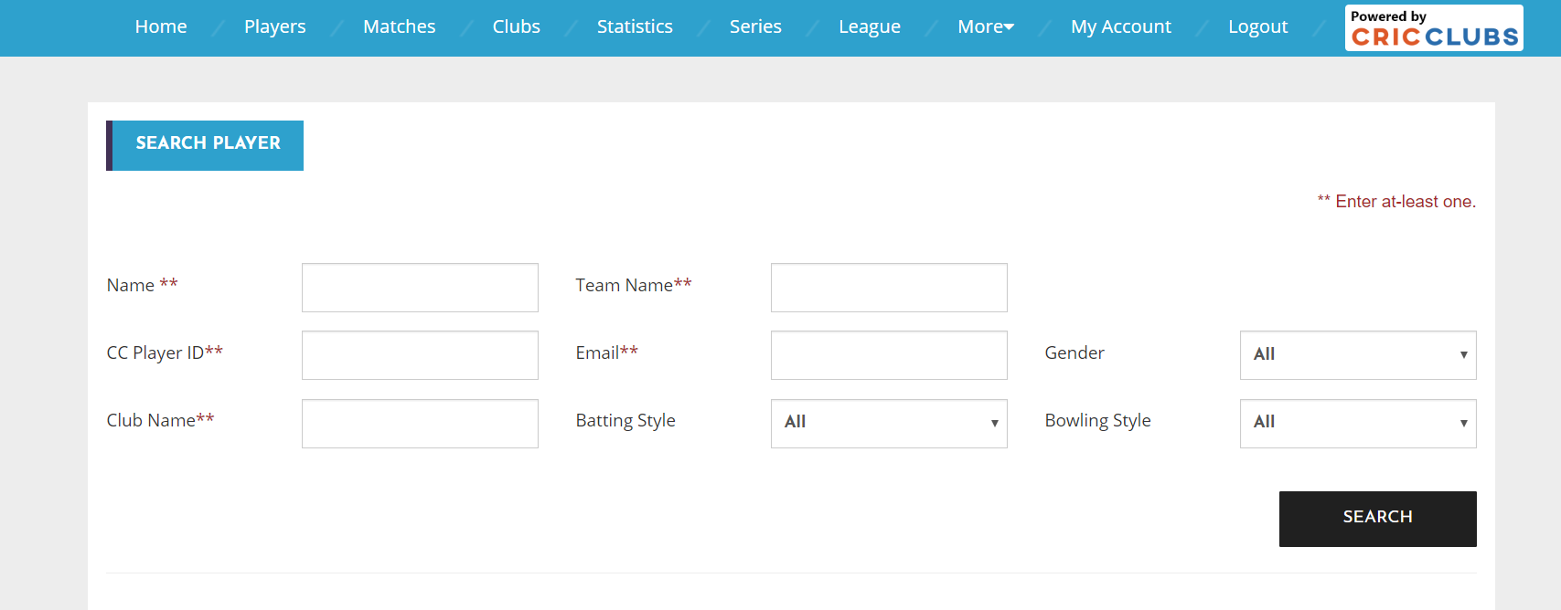
Image 2: View Club Page
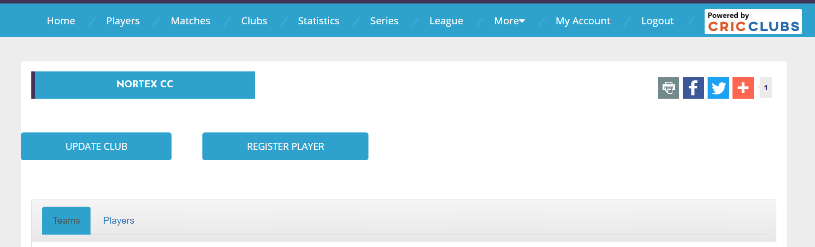

Image 3: Update Club page. (Club Admins only)
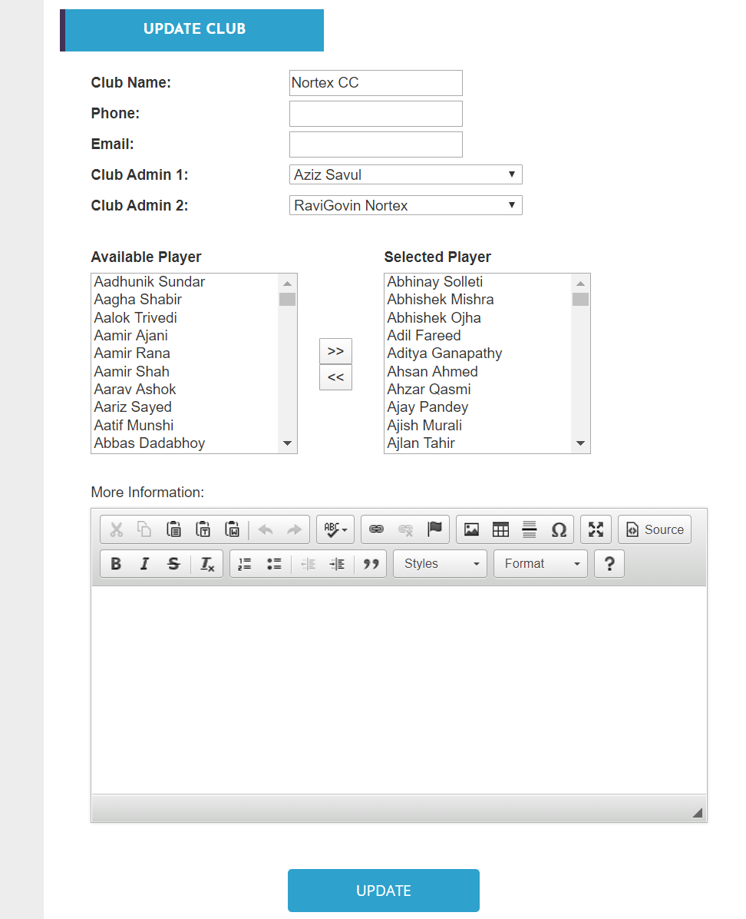

Image 4: View Team. Players listed under Team Info.
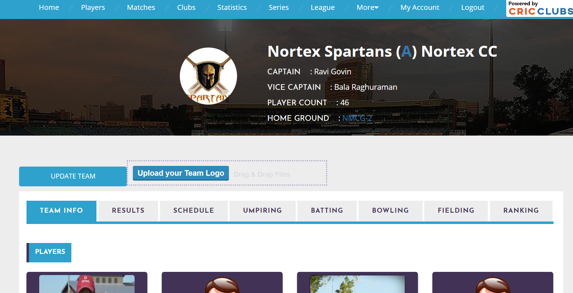

Image 5: Update Team Page. Update buttom at bottom of page
