1. login to www.cricketmilwaukee.com with your username and password. Only the captains can update the score.

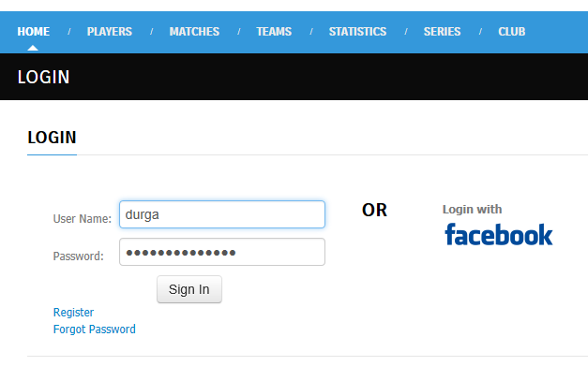

1. Go to **MATCHES** --> **Schedule**

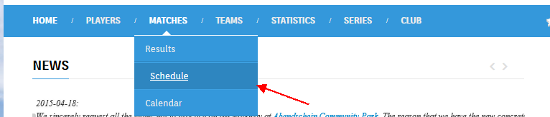

1. It will take you to a list of matches divided into **UPCOMING MATCHES** and **PAST MATCHES** sections.

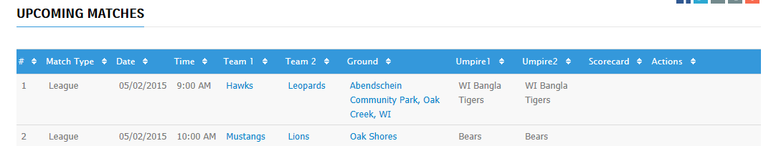

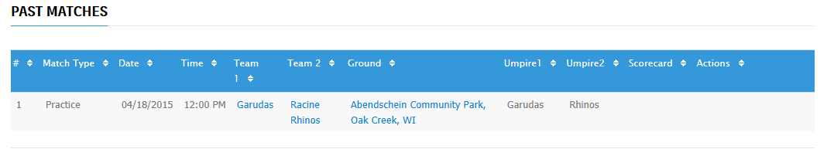

1. Admin actions will be visible only to the captains of both the playing teams.

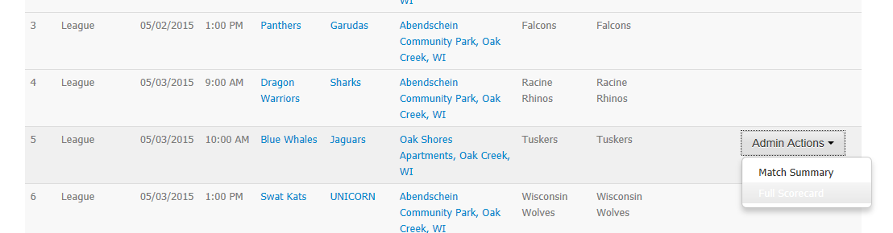

1. Click on Full Scoreboard and enter the scores.

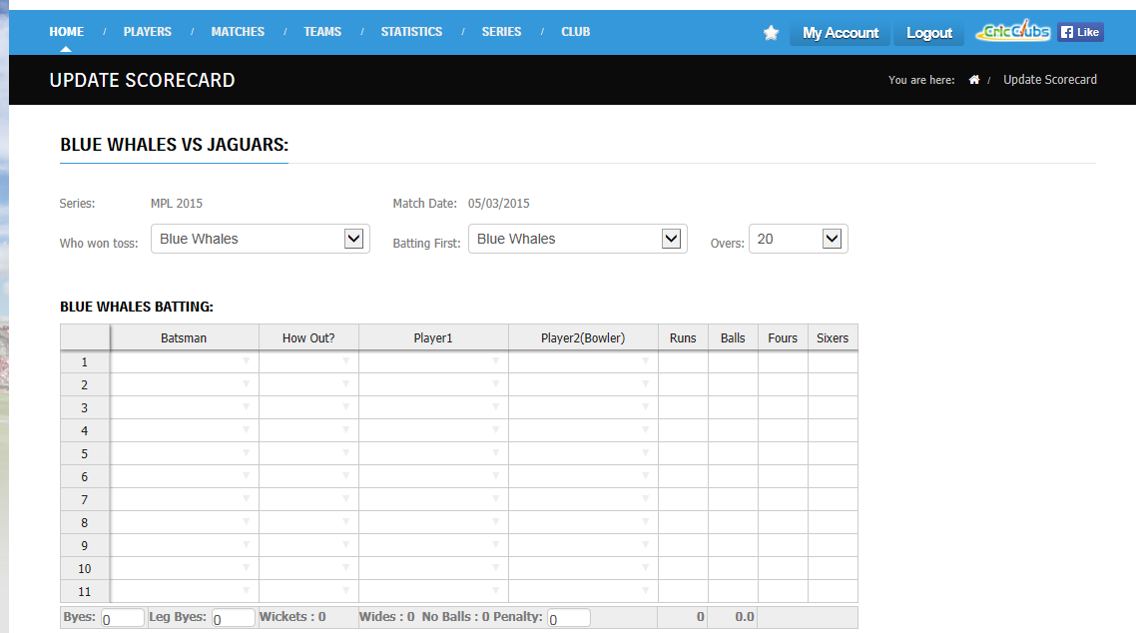

1. Fill in the details in update scorecard page.
2. Rest of the stats will be calculated automatically.