CPL 2018 (Cincinnati Premier League 2018)
1. Each team can have maximum of 14 players in the team roster and only 8 will be playing in a game. No player can play for more than 1 team at any time during the tournament.
2. The league will start on Sunday June 10th 2018. Please see the schedule for more details.
3. In the league round each team will play 14 games.
Total of 20 teams divided into 10 teams each in two groups. Scheduling as below:
- The 4 semifinalists from CPL 2017 will go into two groups through a random draw
- The remaining 16 teams will be drafted into these two groups through a random draft. The teams are divided into two groups based on a lottery may 31st, 2018 in the presence of all the teams
- The league stage will be in two legs
- Leg 1: The 10 teams in a group will play round robin format among themselves, i.e. 9 games each
- At the end of Leg 1, the teams are ranked based on their Points/NRR
- Leg 2: The teams ranked 1, 3, 5, 7 and 9 from Group 1 will each play the teams that are ranked 2, 4, 6, 8 and 10 in Group 2. Similarly, teams ranked 2, 4, 6, 8 and 10 from Group 1 will each play the teams that are ranked 1, 3, 5, 7 and 9 from Group 2
- i.e. 9 games in Leg 1 and 5 games in Leg 2
- At the end of both Leg 1 and 2, the top 8 teams among the 20 teams will move to Quarters
- The standing at the end of Leg 1 are only to decide the schedule for Leg 2, and have no separate weightage for deciding the Quarters standings

5. Below will be the knockout schedule
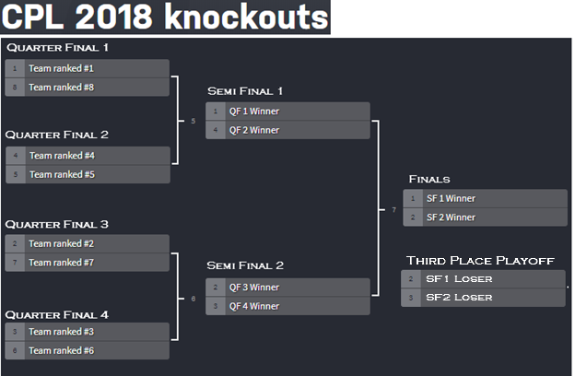
6. There will be trophies for winner, runners-up, best batsman, best bowler of the tournament and finals player of the match and Third place playoff winner.
7. All the matches will be played only on every Sunday.
- Any interruption to a League Match (rain/baseball etc.) in a way that the the game cannot be completed within the scheduled time (for example xx:xx for first game, 11:30 AM for second game) must be considered a draw and points shared
- Interruptions for knockout game must be played within the next Saturday
- Any conflict of opinion between playing teams about the ground condition after a rain interruption must be sorted out by at least two neutral team captains as per availability
- If there are any special requests for game schedule changes, the change must be informed to CPL group for awareness. The game should still be completed before the Saturday of the week following the re-schedule. In any event the game doesn’t happen, teams will split the points for that game
8. All the matches will be played at Heritage Oak Park baseball fields and Nixon Park baseball fields.
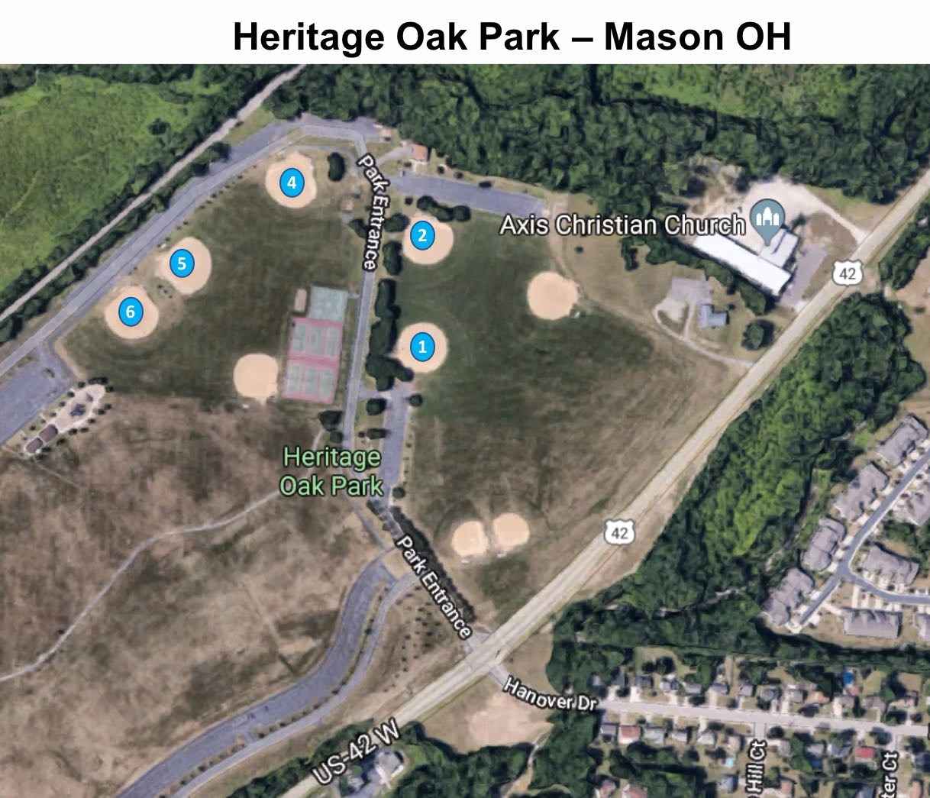
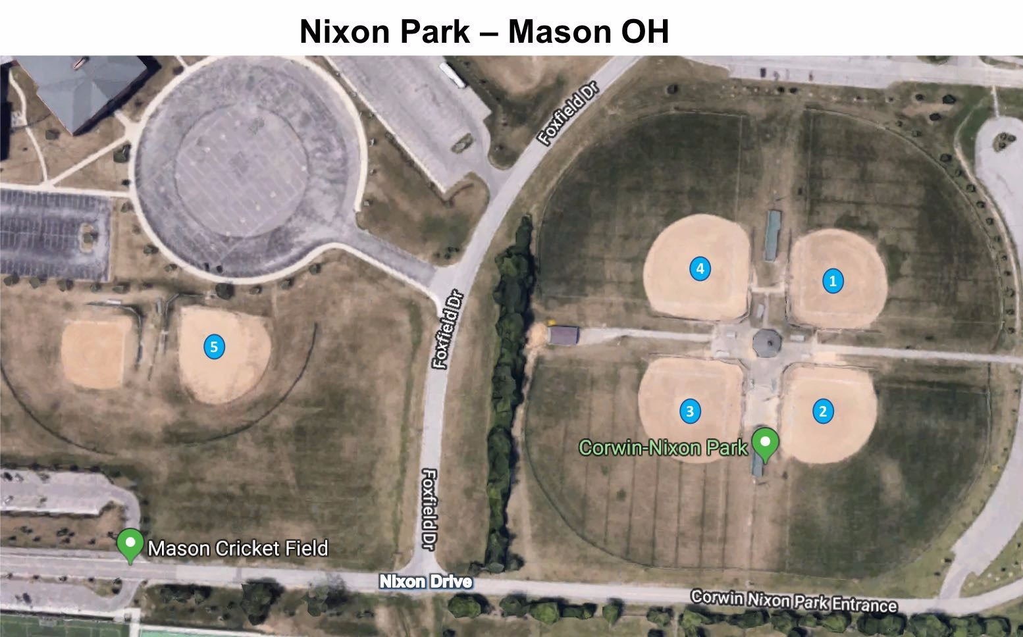
9. It is acceptable if the two playing team’s captains decide and agree on a different playing ground if the change in ground does not affect any other team in the original schedule
10. Ground preparation (cleaning the pitch area), reservation, stumps, setting the pitch as per the attached layout and the boundaries will be the sole responsibility of the teams scheduled to play in that slot. We have commitment with the field authorities that the field playing conditions will not be altered
11. The schedule, scorecard summary and the point’s table will be maintained on CPL2018#CricClubs. The teams are requested to carry printouts of the schedule and scorecards during every match. Try to update scoring live in CPL2018#CricClubs to avoid manual updates
12. It is the responsibility of team captain to update the score in CPL2018#CricClubs before Saturday of the following week after the game day
13. If Neutral umpiring is required, the team captains will need to arrange for the same

14. The scheduled start of the games must be followed as per below. The schedule start is the time at which the first ball must be bowled. Any team not able to start the game by the stipulated time will start to lose overs. Please arrive by 7:45 AM to mark the pitch and field boundaries. This will be captain responsibility to ensure there is representation from their team.
- Team readiness is defined by having a minimum of 6 players on the field and all 8 players for the game declared on scoring sheet or CricClub
- First Game: 08:15 AM – 09:45 AM
- Second Game: 09:45 AM – 11:15 AM
- Team(s) not ready to start the game per schedule will lose One over for every 5 minutes of time lost
15. Sledging is strictly not allowed. Verbal abuse, use of profanities etc. directed at players of the opposing team will result in suspension of one or more players for one or more matches. Under no circumstances will the safety of the players be jeopardized
16. If the umpires are unable to resolve any issues then the available members of the organizing group will intervene and solve the dispute. Whatever the available members of the organizing group decide will be final decision and must be respected by both the team captains. The captains of all the teams form the members of organizing group
17. The members of organizing group are not responsible for any injuries to the players during the games
18. Teams are responsible to keep the grounds in generally clean condition after a match is over. No garbage and other items can be left on the ground
19. The pitch length will be 21 yards or 22 steps
20. The boundary lengths will be 45 yards or 47 steps each side from the middle of the pitch
21. A player must play a minimum of 3 matches during the league stage to be able to play knockout games for the team
Cricket Gear and equipment:
The balls used will be NIVIA hard tennis balls for cricket. 14 balls will be provided to each team for the league games (a new ball MUST be used in each innings) and for knockouts new ball for each innings will be provided. Teams are expected to bring their own bats, gloves, keeping gloves and other cricket gear as appropriate
Points & Knockouts:
1. Each winning team will be awarded 2 points and losing team will get 0 points in league round matches. In case of an abandoned or tied game in the league round matches both teams shall receive a point each. No super over in league games

2. Super-over is played for a tied knockout game. In the unlikely event of a tied super-over, team with higher boundary count will win. Super Over will be one over a side game with 3 batsmen allowed to bat (No single batsman). Next criteria will be the NRR from the league standing if before- mentioned points couldn’t decide a winner.
Game Rules
1. The games will be played under the normal rules of cricket except the LBW laws and leg byes. There are no leg-byes, so a batsman cannot be given run out in the event of a leg-bye. However, if the batsman was genuinely out of the crease after the ball touches him and goes to the keeper, and keeper does the stumping; the stumping would still be valid
2. There will be ten (10) overs per side for the league matches and twelve (12) overs per side in the knockouts
3. In the league matches – Two bowlers per team can bowl a max of 3 overs
Knockouts – Four bowlers can bowl a max of 3 overs
4. Both teams should report to the selected ground field 15 minutes before the start of each game. Teams reporting late could be penalized with 1 over for every 10 minutes up to 3 overs penalty. If more than 30 minutes late, the game will be called off and 2 points awarded to the opposition team. As an alternate option, the team causing the delay will be allowed to start with less number of players to avoid being penalized. They can elect to bat if they win the toss in spite not having all their players present. However, they must field with less players if they end up fielding first. A minimum of 6 players must be present
5. There is no break between the inning
6. The innings will conclude when either all the overs have been bowled or Seven (7) Batsmen have been dismissed. No last man batting allowed. After 7 wickets are lost, it is considered “All Out”. If the team ends up playing with only 7 players, last man standing is allowed
7. Each team has the option to retire active batsmen, so that others can participate. The retired batsman can resume batting after fall of a wicket
8. NO Balls and WIDE Balls shall incur a penalty of one (1) run. There are no bouncer rules and any ball over the batsman's shoulder height while the batsman is standing at the crease will be deemed a No-Ball except when the batsman has advanced down the pitch
Extra Balls shall be awarded for either infringement. (Over) Lines will be marked to assist the umpire in the calling of wide ball
9. The following qualify for “No-balls”:
- Ball clearly above the shoulder height (square leg umpire will call but the main umpire can overrule)
- Ball clearly above the waist on full
- Overstepping by the bowler (front and side creases)
- Back foot crossing the side crease for the bowler
- There is a NO free hit for a No ball resulting from over stepping the crease.
- The bowler fails to give the side (despite 1 umpire warning)
- If the ball hits the stumps on the full and if it is not above the waist, it is a legal ball and not a NO Ball
10. Balls will be called wide under criteria of “playableness”. Anything down the leg side is a wide, unless the batsman has moved to the offside and the ball just missed the stumps or sailed over the stumps. Umpires will make the best decision in such case
11. The LBW law will be negated (not applied). No Leg Byes
12. Wicket keeper can bowl at any time during the match without any wait period
13. In case of injury a substitute fielder will be allowed. The substitute must be drawn from the 14 players registered
14. The only way a batsman can be ruled out in case of a no ball or a free hit is by the way of run-out
15. Only 1 run will be declared irrespective of the ball touching the keeper and crossing the line/fence (orange/red flags) behind the keeper and the batsman will retain the strike. However, if the ball touches any fielder (other than keeper) and the ball goes behind the line/fence, it will be 1 run declared + the runs the batsmen ran before the fielder pushed the ball behind the fence/line
16. The batsman is still out if the fielder catches the ball outside the side line/fence behind the keeper
17. If the ball hits the side fence and stays in the field, the batsman must run between the wickets to score runs
18. If a catch is taken by the fielder who is in contact with the side fence the striking batsman will be given out. However, the ball should not be in direct contact with the boundary fence during the event of the catch
19. If a bowler walks out of the field for 1 over, the bowler need to stay on the field for at least 1 over before bowling the next over
20. If a fielder leaves the field for the last 2 overs in the innings, he will not be allowed to bat for the first 2 overs
21. A player may not make any significant lateral movement after the ball comes into play and before the ball reaches the striker. If this happens, an umpire will call and signal 'dead ball'. Taking a start while the bowler is running into bowl is acceptable. If the ball pitches twice before reaching the stumps (does not matter if the second pitch is inside the batting crease), it will be signaled ‘deal ball’
22. Forfeit of a game in league stages means that the team has played 10 overs without scoring any run, which will reduce the Net Run Rate (NRR)
23. Below is the rule if in any case a game continuity must be decided, for example a rain affected knockout game: In case of rain, the playing captains along-with the umpires will decide the continuity of the game based on the playing conditions. Here are some of the cases and suggested guidelines for each case-
a. Total wash-out or at least one inning is not complete- Playing captains have an option of scheduling an alternate day/time. The game will start afresh. Teams are not required to comprise of same players that were included in the washed-out game. If the game cannot be amicably rescheduled within a reasonable duration, points will be equally shared.
b. One innings completed, second innings is < 5 overs – Start fresh on the rescheduled day.
C. One innings completed, second innings is > 5 overs – Continue the game on the rescheduled day. Do not start fresh.
If the game cannot be amicably rescheduled within a reasonable duration, points will be equally shared.
24. All the games except the last weekend games should be completed before the last weekend. All teams should exactly know what their position in league is and what they should do in their last week’s game to proceed to knockout stage. For the games that are still outstanding (except for last weekend games), the points will be shared and teams just must play their games scheduled for last week. NO EXCEPTIONS.
25. Six runs will be declared based on where the ball pitches outside the boundary line and not based on where it crosses the boundary line in air.
26. If the bowler hits the stumps on the non-striker end during his run up to bowl unintentionally by coming too close to the stump, the ball will be deemed dead. Umpire will signal “Dead Ball”
27. Mankading out is allowed after one warning to the batting team
28. In the event of overthrow when the ball goes behind the fence/line, 1 run will be declared in addition to the number of runs that batsman had run at that point in time

Good Luck, enjoy the game

Fair play

Respect your opponent and our league

